(Approx. 730 words)

This and That
By Elizabeth B. Wright, a member of the Computer Club of Oklahoma City
www.ccokc.org
wright599new(at)sbcglobal.net

Obtained from APCUG with the author's permission for publication by APCUG member groups.

Have you accessed the WindowsXP “Restore” option to reset your computer to an earlier time? We often need to do this when things go haywire after installing some new software. Fiddling around with old programs or offbeat wares can sometimes land you in hot water operating wise. I found myself in just such a mess not long ago. Fortunately I had made a restore point prior to installing the renegade software, so I was able to use it to get things back to normal. Well, almost.

WHAT HAPPENED NEXT:
One of my oldest and most valued programs is CorelPaint. Suddenly, after going through the restore procedure, I began getting an error message plus having the program refuse to open when I double clicked on the desktop shortcut icon. This applied to CorelDraw as well. The error message said something about trying to install the program, then it would go through some strange digital machinations before rolling everything back and giving up. Strangely enough though, if I double clicked on a .jpg or .tif file in Explorer, the files would open the program with no difficulty. Several days were spent opening graphic files in this manner when it suddenly dawned on me that perhaps the programs might open from the executable files directly. Sure enough, when I went to them, again in Explorer, they both opened like clockwork. So why did it take me several more days to figure out that the icons on my desktop had some way become corrupted? I don’t want to know the answer to that one.

Anyway, after deleting the icons, new ones were put in place by right clicking on the executable files in Explorer and double clicking the “Send to desktop” option from the menu. Usually the names given icons made in this way are not the best, so they usually get changed to something more useful on my computer. Often part of the name is “shortcut”. Who needs that? It’s fairly simple to change the name. Just click once on the icon, wait long enough so that the computer doesn’t interpret the next click as a double click, then the icon text will be in “Edit” mode. You may have to experiment with the timing for this since not all “mice” are set for the same response time. The two clicks need to be fairly close together, but not close enough for a double click. Once in “Edit” mode you can type in whatever name that makes better sense to you.

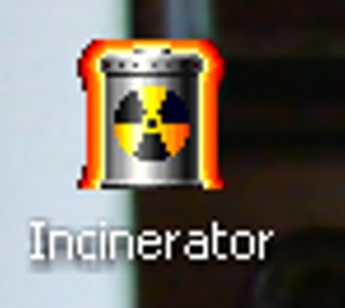

We should all know by now that if there is a curved arrow in the lower left corner of the icon then the icon is a shortcut to the executable file, not the program or file itself. Be very careful. Sometimes there actually are icons for executable programs placed on your desktop when the programs are installed. Those icons will not have the curved arrow. Don’t delete them unless you want to get rid of the program itself. This applies also to other things you might have placed on the desktop yourself, such as graphic or document files. It might be wise to leave those names in their original form. It might also be a good idea to examine the icons on your computer to see how many, if any, DO NOT have the curved arrow. Chances are there won’t be many, possibly none. It is helpful to know if there are any that reflect actual programs or files, just to keep yourself informed about your own computer system.

It always pays to figure out what your computer is up to. Since it lives a life separate from yours it is often not possible to tell just what it has been doing in your absence. With the new powerful operating systems, many, many things go on in the background when the machine is powered on, whether you are there or not. Supernerds probably have eliminated many of the automatic actions, but most of us just muddle on, thankful that the computer runs at all.

This article has been provided to APCUG by the author solely for publication by APCUG member groups. All other uses require the permission of the author (see e-mail address above).

